Q1:

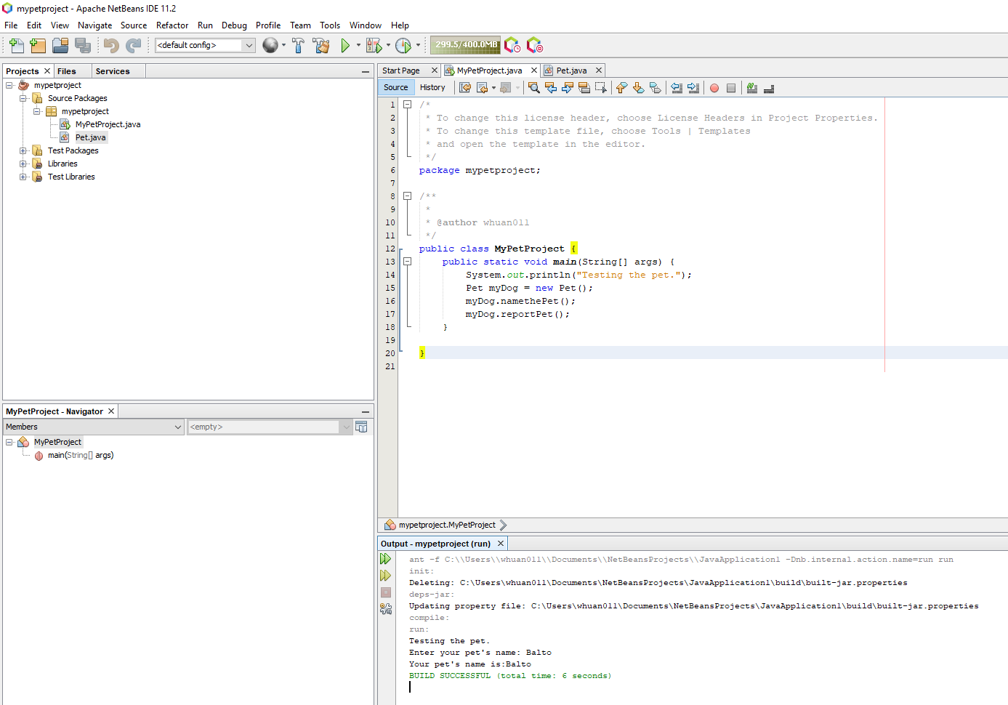

Q2:

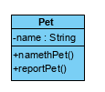

Q3:

|  |  |  |  |
| --- | --- | --- | --- |
| Line # | What happened in this line? | Which class implements this logic? | Which method implements this logic? |
| 1 | Testing pet class | MyPetProject | main |
| 2 | Get pet name | Pet | namethePet |
| 3 | Report pet name | Pet | reportPet |

Q1:

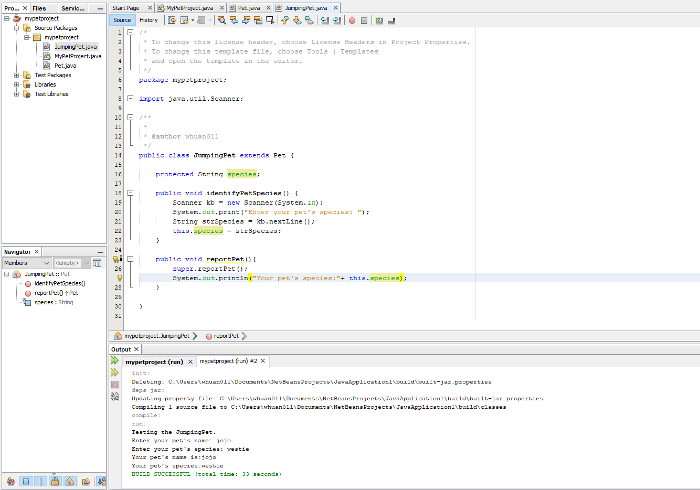

Q2:

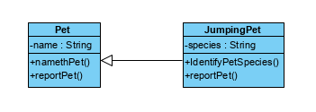

Q3:

|  |  |  |  |
| --- | --- | --- | --- |
| Line # | What happened in this line? | Which class implements this logic? | Which method implements this logic? |
| 1 | Testing pet class | MyPetProject | main |
| 2 | Get pet name | Pet | namethePet |
| 3 | Report pet name | Pet | reportPet |
| 4 | Get pet species | JumpingPet | identifyPetSpecies |
| 5 | Report pet species | JumpingPet | reportPet |